Activity 5 Guide: Spring Security Configuration

Table of Contents
Part 1 – Adding Security to a Spring Boot Application 2
Key Words and Definitions 2
Starting Project 2
Add Dependencies 3
spring-boot-starter-security 3
Security Configuration Class 4
About the Role of the SecurityConfig Class 7
@Configuration 7
@EnableWebSecurity 8
Role of SecurityConfig in Login and Security Filtering 8
UserService vs UserDetailsService 9
Comparison 9
Key Processes 9
Password Encoding Config 9
Comparison Table of Hashing Algorithm Options 10
Recommendation 11
Update User Service for Password Encoding and Spring Authentication 11
Key Updates in UserService class 13
About the UserDetailsService 14
Comparison of User object and UserModel class 14
Update Login Form 14
Key Updates 15
Update the User Controller 16
Key Differences 18
Test the Application 19
Debugging 19
Secure Individual Pages and Methods in the Orders Controller 20
Part 2 – Thyme leaf Security Integration 21
What can you do with Thymeleaf and Security? 21
Update the Application to user Thymeleaf Security Extras 22
Key Takeaways: Spring Security Configuration 25
Check for Understanding 26
Deliverables: 28

Part 1 Adding Security to a Spring Boot Application
In this lesson, you will learn how to transform an existing Spring Boot application into a secure application using Spring Security. This step-by-step tutorial will guide you through the process of securing your application, ensuring that only authenticated and authorized users can access its features. By the end of this tutorial, you will have a thorough understanding of how to implement security in a Spring Boot application, including user authentication and authorization.

Key Words and Definitions
- Spring Security: A set of dependencies, configurations and settings used to secure access to application features in a Spring Boot application.
- Authentication: The process of verifying the identity of a user, typically done through username and password.
- Authorization: The process of determining if an authenticated user has the necessary permissions to access a particular resource.
- Filters: Java classes used to perform tasks on either the request to a resource or the response from a resource before the request reaches the controller.
- Filter Chain: A sequence of filters applied to a request in a specific order to perform authentication, authorization, and other security tasks.
- UserDetailsService: An interface used to retrieve user-related data, typically implementing methods to load user-specific data from a data source.
- PasswordEncoder: An interface for encoding passwords, ensuring they are stored securely using hashing algorithms like BCrypt.
- Method Security: The practice of securing individual methods within Spring beans using annotations to specify security constraints.
- GrantedAuthority: Represents an authority granted to an authenticated user such as USER or ADMIN.

Starting Project
- Download the file CST-407-RS-T5-Activity-5-Spring-Security-Starting-Code.zip, which should be attached to this activity.
- Unzip the application.
- Open the projec in a Java IDE.
- Add the associated ordersapproles.sql database to mySQL.

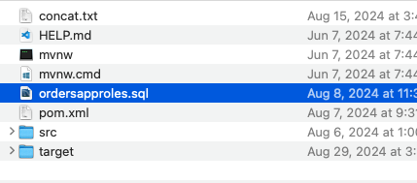
Figure 1 ordersapproles.sql is included in the zip file.
- Run the application. There should be no restriction on any page. No authorization checks are made before performing "create," "edit," or "delete" operations.

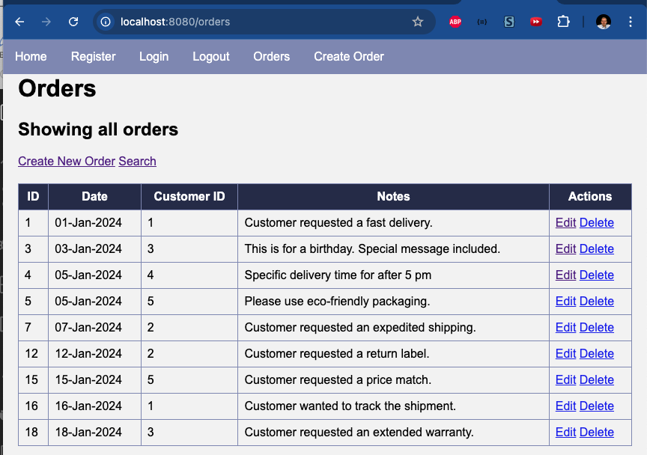
Figure 2 The Orders application manages a list of objects using standard CRUD operations.

Add Dependencies
To enable Spring Security, we need to add spring-boot-starter-security to the pom.xml file.

spring-boot-starter-security
<dependency>
<groupId>org.springframework.boot</groupId>
<artifactId>spring-boot-starter-security</artifactId>
</dependency>
This dependency is a collection of other security dependencies for authentication and authorization. The security dependencies included in the starter group include:
spring-security-core whose classes include:
- AuthenticationManager
- UserDetails
- User
- BCryptPasswordEncoder
- GrantedAuthority
spring-security-config whose classes include:
- WebSecurityConfigurerAdapter
- HttpSecurity
- AuthenticationManagerBuilder
spring-security-web whose classes include:
- UsernamePasswordAuthenticationFilter
- LogoutFilter
- BasicAuthenticationFilter
- RememberMeAuthenticationFilter
- CsrfFilter
- SecurityContextPersistenceFilter

Security Configuration Class
- Create a new folder "config" in the project, as shown in Figure 2.

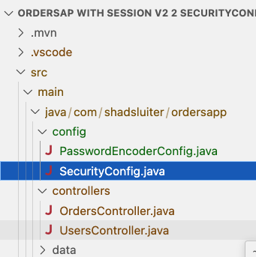
Figure 3 config folder is added to the project.

- Create a new class SecurityConfig.java in the config folder.
The file SecurityConfig.java file name is a common convention. It is good to name the security configuration class in a way that indicates that the class is responsible for configuring security settings in a Spring Boot application.
- Figure 3 shows the code to be used for SecurityConfig:
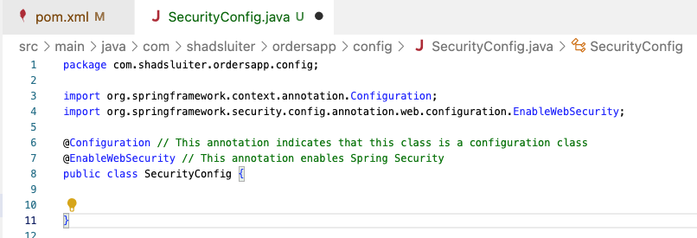
Figure 4 Code needed.
Figures 4 through 7 show next steps.
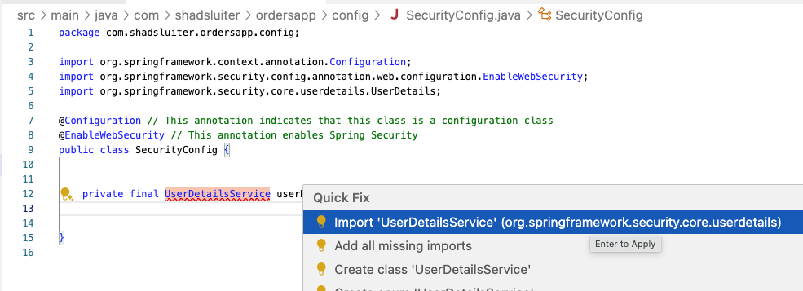
Figure 5 Importing information.

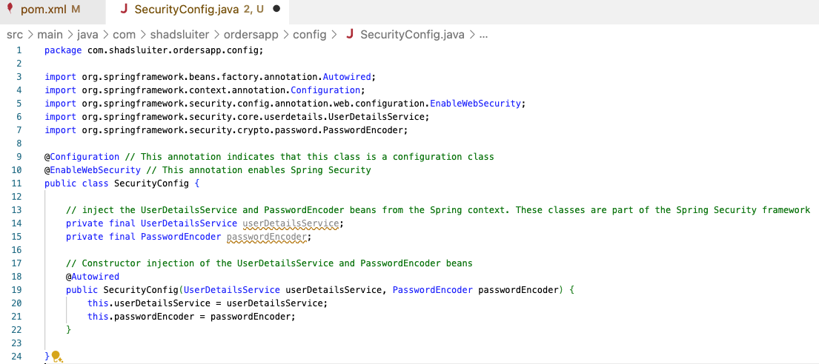
Figure 6 Once information has been imported.

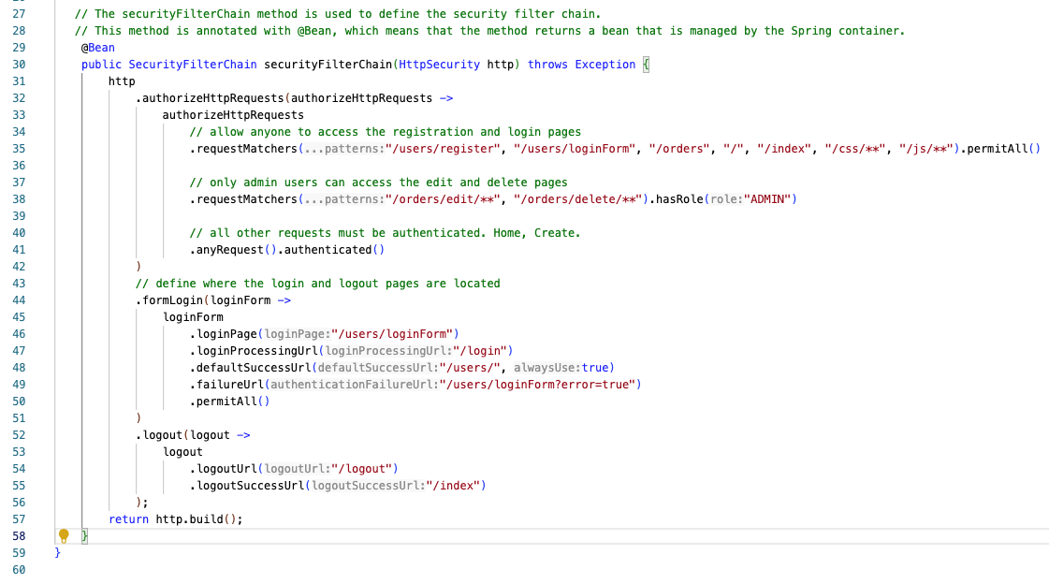
Figure 7 Defining pages.

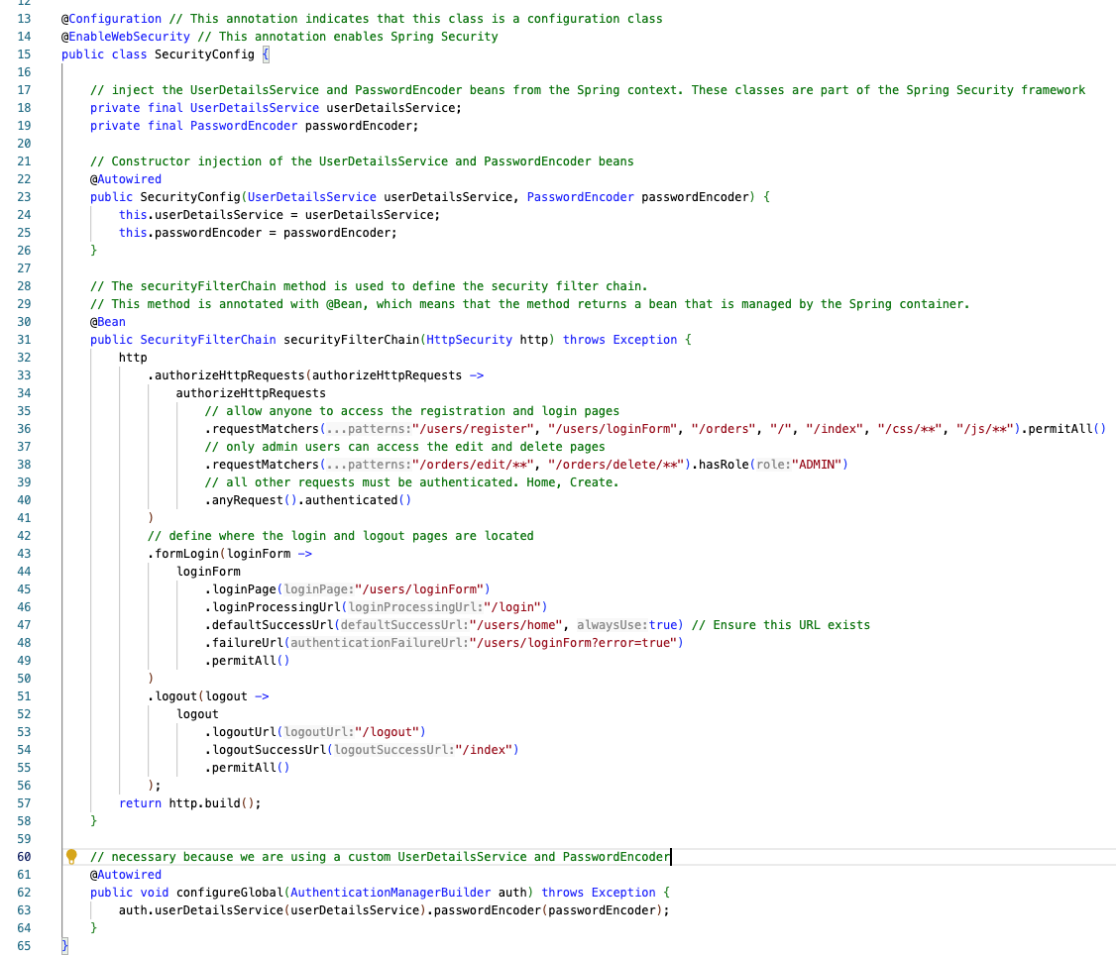
Figure 8 End result.

About the Role of the SecurityConfig Class
The SecurityConfig class manages login and security restriction filtering processes.
Annotations:

@Configuration
- Purpose: Indicates that this class contains Spring Beans definitions.
- When Spring Boot references this: During the application startup, Spring Boot scans for classes annotated with @Configuration to identify beans that need to be instantiated and managed by the Spring container.

@EnableWebSecurity
- Purpose: Enables Spring Security’s web security support and integrates it with the Spring MVC framework.
- When Spring Boot references this: When the application starts up, Spring Boot looks for classes annotated with @EnableWebSecurity to configure the security settings of the application.

Role of SecurityConfig in Login and Security Filtering
- Login Handling: The formLogin method in configure sets up the login process. When a user accesses a secured URL, they are redirected to the login page at /login. This URL is different from the first version of the application. After successful login, users are redirected to the default page.
Security Filtering: The authorizeRequests method configures which URLs require authentication. For example, any URL that does not start with /users/register", "/users/loginForm", "/orders", "/", "/css/**", "/js/**" requires the user to be authenticated.
- Constructor Injection:
  - The constructor injects UserDetailsService (implemented by UserService) and PasswordEncoder. These components are needed for authentication and password management.
- SecurityFilterChain Bean:
  - Configures the security filter chain, which defines how security is applied to HTTP requests.
  - authorizeHttpRequests: Configures URL-based security. Specific paths are permitted without authentication (e.g., /users/register, /users/loginForm), while others are restricted based on roles (e.g., /orders/edit/** is restricted to users with the ADMIN role).
  - formLogin: Configures the form login process, including the login page, login processing URL, default success URL, and failure URL.
  - logout: Configures the logout process, including the logout URL and the URL to redirect to after logout.
- Global Authentication Configuration:
  - The configureGlobal method sets up authentication by specifying the UserDetailsService and PasswordEncoder. This ensures that the application uses the custom user service for loading user details and the specified password encoder for password matching.

UserService vs. UserDetailsService
- Typically, UserService is a custom service class created by developers to handle user-related operations such as creating, updating, deleting, and retrieving user information from the database.
- UserDetailsService is an interface provided by Spring Security. It is used to retrieve user-related data for authentication and authorization purposes. The core method defined in this interface is loadUserByUsername.

Comparison
Feature | UserService | UserDetailsService
Purpose | Handle general user-related operations | Retrieve user details for authentication
Core Functionality | Create, update, delete, and find users | Load user details by username
Spring Security Role | General service, not specific to security | Integral to Spring Security authentication
Typical Methods | save, update, delete, find by attributes | loadUserByUsername
Return Type | Application-specific user model (e.g., UserModel) | Spring Security's UserDetails
Integration | Used throughout the application wherever user operations are needed | Used by Spring Security during login process

Key Processes
- Authentication:
  - The UserDetailsService loads user-specific data, including username, password, and roles, which is used to authenticate users during login.
  - The PasswordEncoder is used to verify passwords securely using a hashing method.
- Authorization:
  - The URL-based security configurations (authorizeHttpRequests) determine which users have access to which URLs based on their roles.
- Form Login:
  - Customizes the login process, specifying the login form URL, the URL to process login submissions, the default success URL after login, and the URL to redirect to upon login failure.
- Logout:
  - Customizes the logout process, specifying the logout URL and the URL to redirect to after a successful logout.

Password Encoding Config

- Add a new file PasswordEncodingConfig.java in the config folder, as seen in Figure 8.
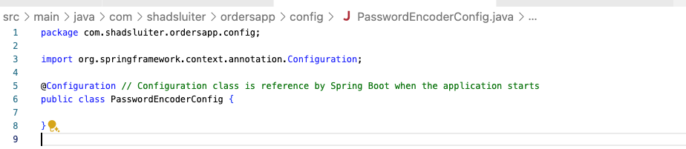
Figure 9 Adding a new file.

- Add the following code to use BCrypt hashing, as seen in Figure 9.

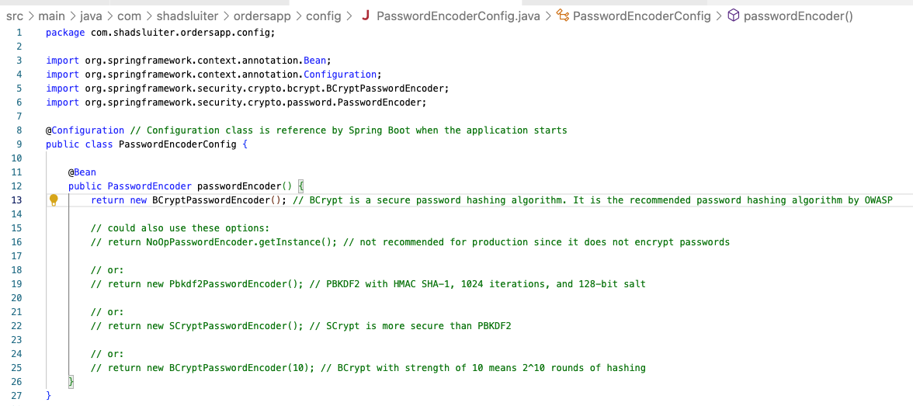
Figure 10 Use BCrypt hashing.

Comparison Table of Hashing Algorithm Options
Algorithm | Security | Performance | Strengths | Weaknesses
BCryptPasswordEncoder | High | Medium | Resistant to rainbow table attacks, adjustable work factor | Slower than simple hashes like MD5
NoOpPasswordEncoder | None | Very High | Fastest, useful only for testing | Not secure at all, should not be used
Pbkdf2PasswordEncoder | High | Medium-High | Industry standard, configurable key length and iterations | Computationally expensive
SCryptPasswordEncoder | Very High | Low-Medium | High resistance to custom hardware attacks | Memory-intensive, slower than BCrypt
Argon2PasswordEncoder | Very High | Medium | Highly secure, winner of PHC, highly configurable | Requires careful configuration

Recommendation
- For Production: Use BCryptPasswordEncoder, Pbkdf2PasswordEncoder, SCryptPasswordEncoder, or Argon2PasswordEncoder.
- For Testing: Use NoOpPasswordEncoder only in non-production environments for simplicity.

Update User Service for Password Encoding and Spring Authentication

See Figure 10 for how to update user service for password encoding and Spring Authentication.

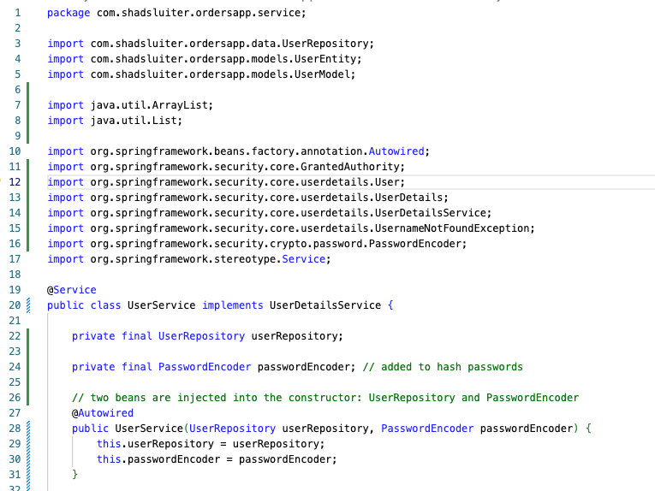

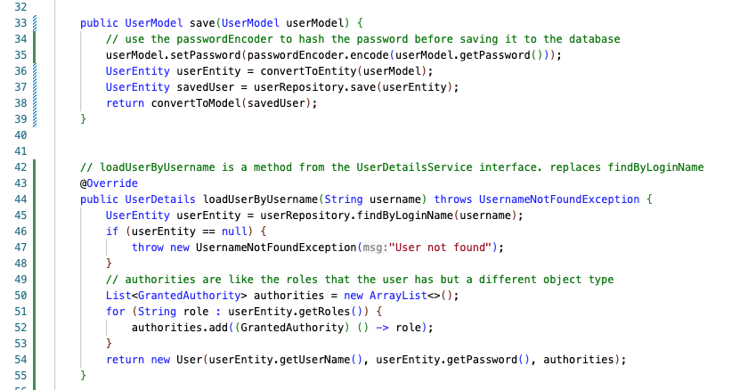
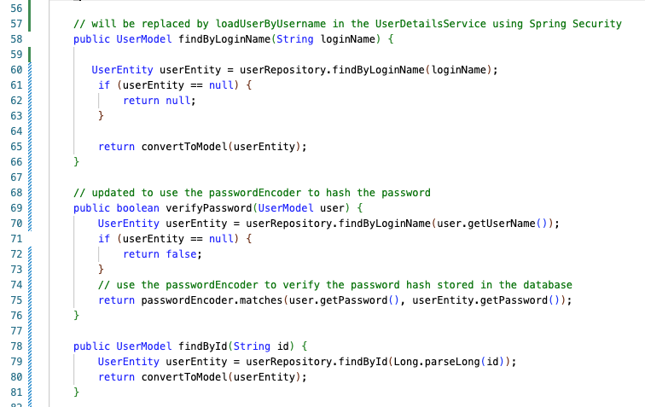
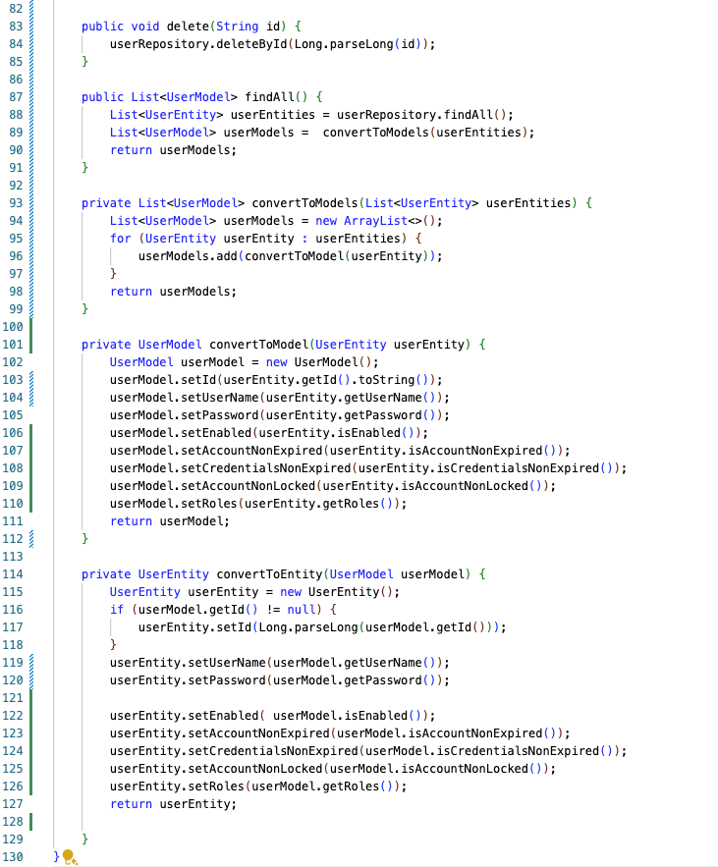
Figure 11 Code used to update user service for password encoding and Spring Authentication.

Key Updates in UserService Class
- Implementation of UserDetailsService Interface:
  - Implements UserDetailsService and provides the loadUserByUsername method for integrating with Spring Security.
- Password Encoding:
  - Uses PasswordEncoder to encode passwords before saving them.
- Password Verification:
  - Has a commented-out verifyPassword method because Spring Security handles password verification.
  - Previously: Includes a verifyPassword method that compares plain text passwords.
- Authorities and Roles:
  - In loadUserByUsername, assigns default roles (ROLE_USER, ROLE_ADMIN) to the authenticated user.
  - Previously: Did not handle roles or authorities since it does not integrate with Spring Security.
- Security Integration:
  - Fully integrated with Spring Security, using UserDetailsService to load user details for authentication.

About the UserDetailsService
The UserService class implements UserDetailsService, which is a core interface in Spring Security used to retrieve user-related data for authentication. You will not find the UserDetailsService class in the project.
The key method of UserDetailsService is loadUserByUsername(String username)
- Loads the user details by username for authentication purposes.
- Steps:
  - Finds the UserEntity by login name using userRepository.
  - If the user is not found, throws UsernameNotFoundException.
  - Creates a list of GrantedAuthority (roles/permissions).
  - Returns a Spring Security User object (distinct from UserModel class) with the user's login name, password, and authorities.

Comparison of User object and UserModel class
Feature | User Object (Spring Security) | UserModel Class (Application-Specific)
Purpose | Represents authenticated user details for security | Represents user data for application logic and data transfer
Structure | Username, password, granted authorities | ID, username, password, and potentially other user data
Usage | Used by Spring Security for authentication and authorization | Used throughout the application for managing user data
Creation | Created by the UserDetailsService implementation | Created and managed by application service and repository layers
Integration | Integral to Spring Security's authentication process | Integral to the application's business logic and data storage

Update Login Form
Modify the login and registration forms to handle authentication through the Spring Security filter chain instead of the UsersController. See Figures 11 and 12 for details.
Login Form (login.html):
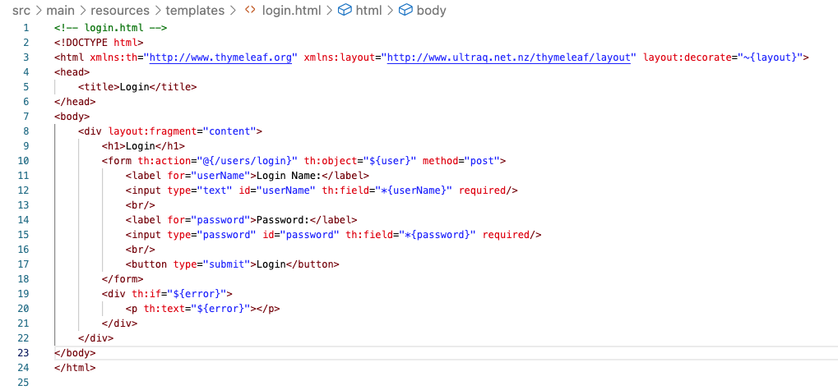
Figure 12 Currently, the form is set to use the userModel object with userName and password as properties.

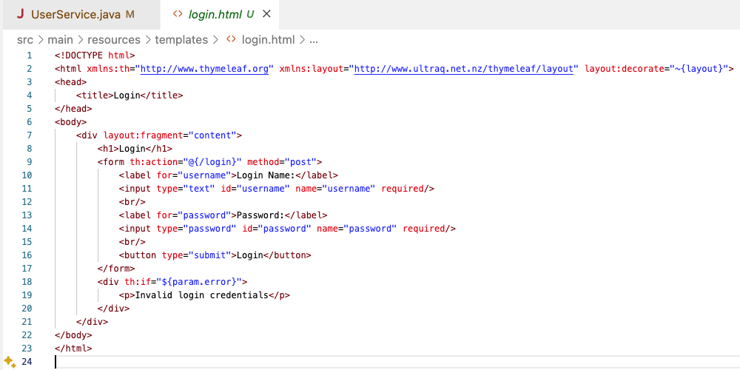
Figure 13 Update the form to change the URL /login, the userName to username. Password is spelled the same. No binding with userModel object is done in this form.

Key Updates
- Form Action URL:
  - Original The form action is @{/users/login}, indicating that the login form will be submitted to the /users/login endpoint which was part of the UsersController (now removed in favor of Spring Security).
  - Update: The form action is @{/login}, indicating that the login form will be submitted to the /login endpoint, which is part of the Spring Security filter chain.
- Thymeleaf Object Binding:
  - Original: The form uses th:object="${user}" to bind the form fields to a user object. This means that the form fields will be bound to the properties of the user object.
  - Update: The form does not use object binding with th:object
- Field Names:
  - Original: Uses th:field="*{userName}" and th:field="*{password}" to bind the form fields directly to the userName and password properties of the user object.
  - Update: Uses standard HTML name attributes (name="username" and name="password") without Thymeleaf object binding. The username and password are part of the user object in Spring Security.
- Error Handling:
  - Original: Uses th:if="${error}" and th:text="${error}" to display an error message if there is an error attribute in the model.
  - Update: Uses th:if="${param.error}" and displays a static error message "Invalid login credentials" if the error parameter is present in the request.

Update the User Controller
Ensure the controller uses the new security configurations, as shown in Figure 13.
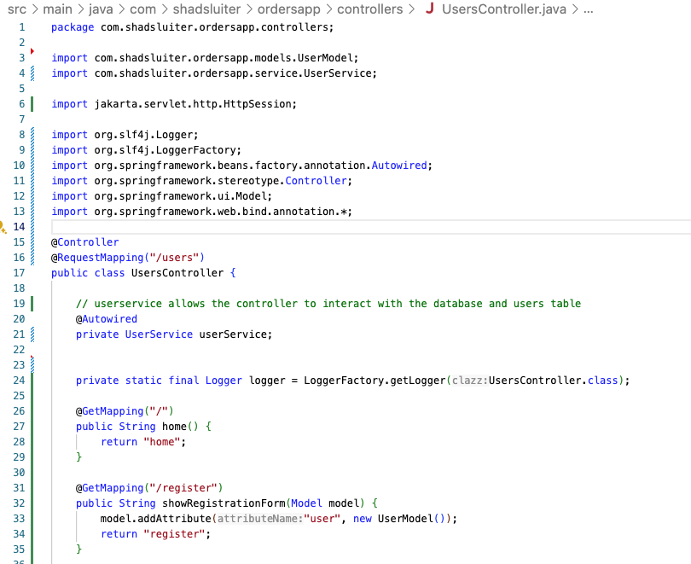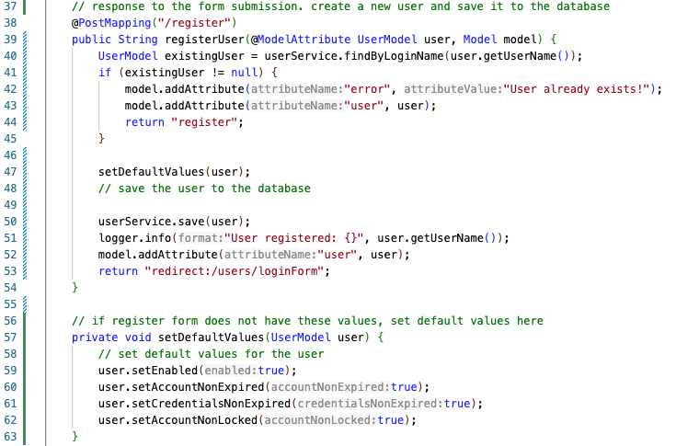
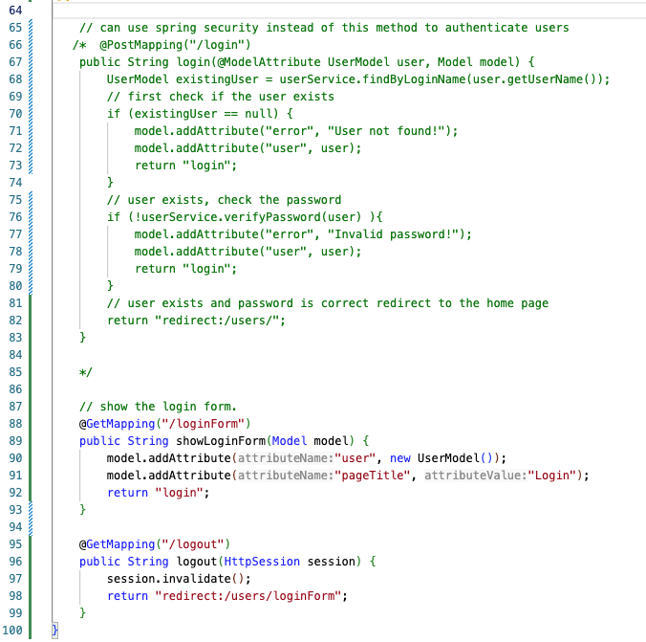
Figure 14 Ensure the controller uses the new security configurations.

Key Differences
- Removed Login Method:
  - Original Version: Contains a @PostMapping("/login") method that handles user login by checking user existence and password correctness.
  - New Version: This method is commented out, indicating a shift to using Spring Security's built-in login functionality.
- Logout Method Enhancement:
  - Original Version: The logout method simply redirects to the login form without any session management.
  - New Version: The logout method now takes an HttpSession parameter and invalidates the session to properly log out the user.
- Imports:
  - New Version: Uses jakarta.servlet.http.HttpSession for session management.
  - Original Version: Does not use HttpSession for logout handling.

- The UserController is no longer responsible for processing logins. Spring SecurityConfig relies on the UserService and implements UserDetailsService and the method loadUserByUsername method, as seen in Figures 14 and 15.
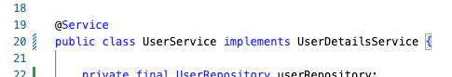
Figure 15 UserService implements UserDetailsService.
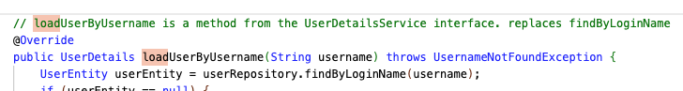
Figure 16 loadByUsername is called by SecurityConfig settings when a login occurs. This method is implemented to fullfill the UserDetailsService interface.

Test the Application
Run the application and ensure that users can register, log in, and access protected resources.
- Register a new user.
- Log in with the new user.
- Access protected resources (e.g., /orders, create, edit).
- Logout
- Attempt to access protected resources.

Debugging
- Place a break point in the UserService class in the loadUserByUsername method.
- Run the application in debug mode, as seen in Figure 16.
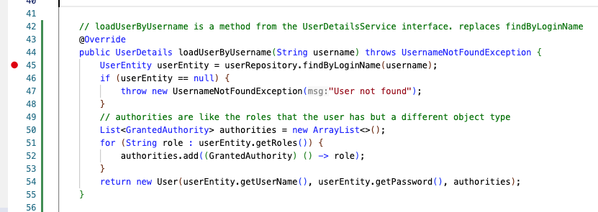
Figure 17 Debug mode.

- The application should stop when you attempt a login, as seen in Figures 17 and 18.

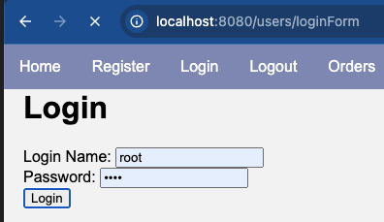
Figure 18 Login with a valid account name and password.

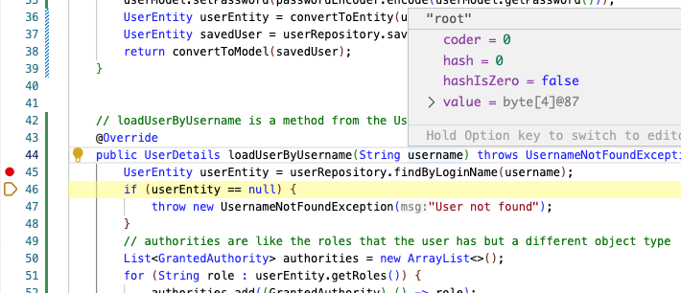
Figure 19 During debug, the username value is shown as "root" which matches the username in the login.html form.


- Take a screenshot of the running application at this point.
- Paste the image into a Microsoft Word document.
- Put a caption below the image explaining what is being demonstrated.

Secure Individual Pages and Methods in the Orders Controller
In addition to the filter chain in the SecurityConfig file, you can secure individual pages and controller methods using annotations like @PreAuthorize
@PreAuthorize("hasRole('ROLE_USER')")// only USER accounts can get all orders
@GetMapping("/orders")
public String getAllOrders(Model model) {
List<OrderModel> orders = orderService.findAll();
model.addAttribute("orders", orders);
model.addAttribute("pageTitle", "Orders");
return "orders";
}

You can configure access to pages in both the OrdersController and the Security Config file. Both approaches are valid, and the choice depends on the specific needs and design of your application.

Using Annotations like @PreAuthorize: | Using Configuring in SecurityConfig with Filter Chain
Security rules are close to the business logic they apply to. | Centralized management: All security rules are in one place, making it easier to manage.  Consistency: Ensures that security rules are consistently applied.
Scattering: Security rules might be scattered across many classes and methods.  Maintenance: Harder to maintain and audit all security rules in a large application. | Filter chain configurations can become harder to understand and maintain.

Part 2 Thymeleaf Security Integration

What can you do with Thymeleaf and Security?
- Authorization Tags are used to conditionally display parts of a template based on the current user's roles or authorities.
<div sec:authorize="hasRole('ADMIN')">
This content is only visible to users with the ADMIN role.
</div>
- Authentication Tags are used to display information about the authenticated user.
<p>Welcome, <span sec:authentication="name"></span>!</p>
- Access Control Expressions support various expressions for access control checks, such as isAuthenticated(), isAnonymous(), hasRole(), hasAuthority(), etc.

<li sec:authorize="isAuthenticated()">
<a th:href="@{/logout}">Logout</a>
</li>
- Conditional Rendering allows the app to display content based on the logged in user.
  - sec:isAuthenticated() renders content only if the user is authenticated.
  - sec:isAnonymous() renders content only if the user is not authenticated.
  - sec:hasRole('ROLE_USER') renders content only if the user has a specific role.
  - sec:hasAnyRole('ROLE_USER', 'ROLE_ADMIN')": renders content if the user has any of the specified roles.
- Display User Details allow you to show properties of the authenticated user, such as username and authorities (roles).
<p>User: <span sec:authentication="name"></span></p>
<p>Authorities: <span th:each="auth : ${#authentication.principal.authorities}" th:text="${auth.authority}"></span></p>

Update the Application to user Thymeleaf Security Extras

  - Update pom.xml to include Thymeleaf extras for Spring Security.

<!-- Thymeleaf Extras for Spring Security -->
<dependency>
<groupId>org.thymeleaf.extras</groupId>
<artifactId>thymeleaf-extras-springsecurity6</artifactId>
</dependency>

  - Check the Compatibility with Spring Security:
- thymeleaf-extras-springsecurity5 is compatible with Spring Security 5.x.
- thymeleaf-extras-springsecurity6 is compatible with Spring Security 6.x.
You can see the version of Spring Security in the Maven dependencies folders, as seen in Figure 19.
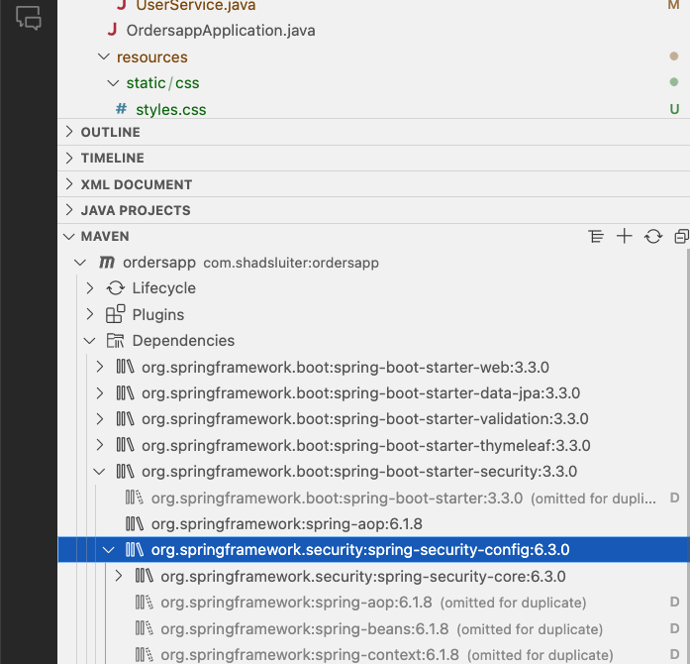
Figure 20 Version 6.3.0 of spring-security-config is in this application.
This application has spring-boot-starter-security:3.3.0 , but the internal folder shows spring-security-config:6.3.0. You should use thymeleaf-extras-springsecurity6.

  - Update the layout for the navbar using the new Thymeleaf tags, as seen in Figure 20.
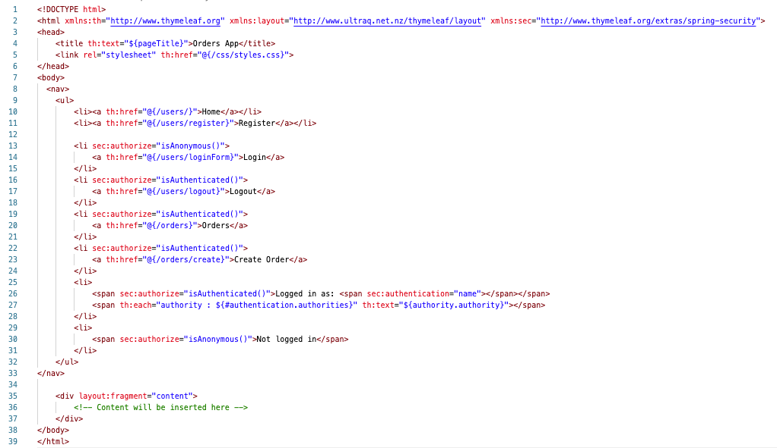

Figure 21 nabar checks for login status before displaying some links. It displays the login name and roles the user has.

- Test the application. You should see certain links only when you are logged in, as seen in Figures 21 and 22.

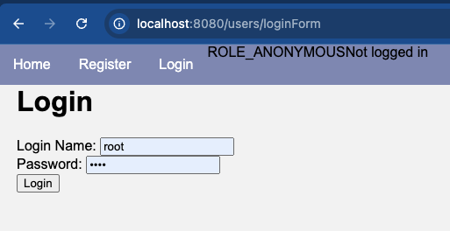
Figure 22 Some links in the navbar are hidden because the user has not logged in yet.


- Take a screenshot of the running application at this point.
- Paste the image into a Microsoft Word document.
- Put a caption below the image explaining what is being demonstrated.

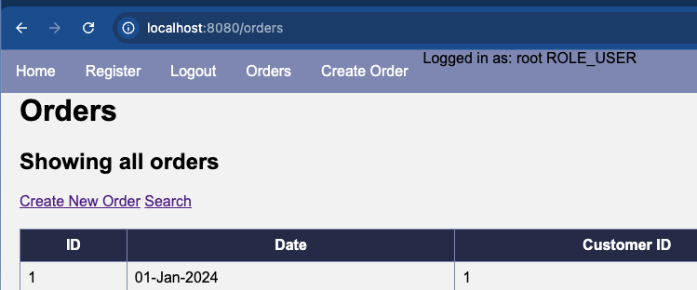
Figure 23 Links in the navbar are visible when a user is logged in.


- Take a screenshot of the running application at this point.
- Paste the image into a Microsoft Word document.
- Put a caption below the image explaining what is being demonstrated.

Key Takeaways: Spring Security Configuration
- Securing a Spring Boot Application:
  - Overview: You learned how to transform a basic Spring Boot application into a secure one using Spring Security. The lesson covered the essential steps to add user authentication and authorization, ensuring that only authorized users can access specific features of your application.
  - Key Components:
    - Spring Security Setup: You integrated Spring Security into your project by adding the necessary dependencies and creating a SecurityConfig class. This class is crucial for managing login processes and security filtering.
    - UserService and UserDetailsService: You explored the differences between these two services. The UserService handles general user operations, while UserDetailsService is integral to Spring Security, facilitating the retrieval of user data for authentication.
- Implementing Password Security:
  - Overview: You learned how to securely store user passwords by implementing password encoding using different hashing algorithms.
  - Key Updates:
    - Hashing Algorithms Comparison: You compared various hashing options like BCrypt, Pbkdf2, SCrypt, and Argon2, understanding their strengths and weaknesses to choose the best one for your application.
    - UserService Integration: You updated the UserService class to incorporate password encoding, ensuring secure user authentication.
- Integrating Thymeleaf with Spring Security:
  - Overview: You discovered how to use Thymeleaf in conjunction with Spring Security to control content visibility based on user roles and authentication status.
  - Key Features:
    - Authorization and Authentication Tags: You learned to conditionally display content on your web pages depending on whether a user is logged in and their assigned roles.
    - Access Control Expressions: You explored various expressions that allow you to enforce security rules directly in your Thymeleaf templates.
- Testing and Debugging Your Application:
  - Testing: You were guided through the process of testing your application to ensure that all security measures are correctly in place.
  - Debugging: You learned how to troubleshoot and debug issues, particularly those related to user authentication, by setting breakpoints and examining the flow of the application.

Check for Understanding
Although not graded, these questions will prepare you for upcoming assessments.
1. Which dependency is essential for adding Spring Security to a Spring Boot application?
- A) spring-boot-starter-web
- B) spring-boot-starter-data-jpa
- C) spring-boot-starter-security
- D) spring-boot-starter-thymeleaf
Correct Answer: C) spring-boot-starter-security
2. What is the role of the @EnableWebSecurity annotation in the SecurityConfig class?
- A) It indicates that the class contains Spring Beans definitions.
- B) It enables Spring Security's web security support and integrates it with Spring MVC.
- C) It configures the security filter chain.
- D) It sets up the login process.
Correct Answer: B) It enables Spring Security's web security support and integrates it with Spring MVC.

3. Which method in the SecurityConfig class is responsible for configuring URL-based security?
- A) formLogin
- B) logout
- C) authorizeHttpRequests
- D) configureGlobal
Correct Answer: C) authorizeHttpRequests
4. What does the UserDetailsService interface provide in Spring Security?
- A) Methods to handle general user-related operations.
- B) Methods to retrieve user details for authentication.
- C) Methods to manage security filters.
- D) Methods to encode passwords.
Correct Answer: B) Methods to retrieve user details for authentication.
5. Which of the following hashing algorithms is recommended for production environments in Spring Security?
- A) NoOpPasswordEncoder
- B) BCryptPasswordEncoder
- C) MD5PasswordEncoder
- D) SHA256PasswordEncoder
Correct Answer: B) BCryptPasswordEncoder
6. When should the NoOpPasswordEncoder be used in a Spring Boot application?
- A) In production environments for maximum security.
- B) In non-production environments for simplicity and testing.
- C) For encoding passwords with strong encryption.
- D) For storing passwords in plaintext securely.
Correct Answer: B) In non-production environments for simplicity and testing.
7. What is the purpose of the loadUserByUsername method in the UserDetailsService implementation?
- A) To create new users in the database.
- B) To load user details for authentication purposes.
- C) To configure the security filter chain.
- D) To handle password encoding.
Correct Answer: B) To load user details for authentication purposes.
8. Which of the following is a key feature provided by Thymeleaf Security integration?
- A) Form submission without security filters
- B) Conditional rendering based on user roles
- C) Automatic password encoding
- D) Session management
Correct Answer: B) Conditional rendering based on user roles
9. Which of the following statements about the PasswordEncoder interface is true?
- A) It is used to retrieve user details for authentication.
- B) It is used to encode and verify passwords securely.
- C) It is used to configure URL-based security in the SecurityConfig class.
- D) It is responsible for managing user sessions.
Correct Answer: B) It is used to encode and verify passwords securely.
10. What is the primary purpose of the SecurityConfig class in a Spring Boot application?
- A) To handle general user operations like creating and updating users.
- B) To configure security settings, including authentication and authorization.
- C) To manage the database connections for the application.
- D) To handle form submissions in the application.
Correct Answer: B) To configure security settings, including authentication and authorization.

Deliverables:
- Submit a Microsoft Word document with screenshots of the applications being run. Show each screen of the output and put a caption under each picture explaining what is being demonstrated.
- In the same document, write a summary of the key concepts that were demonstrated in this lesson including:
  - What key classes are used in Spring Security configuration?
  - Explain the filter chain and how it interacts with controller methods.
- Convert the Microsoft Word document to a PDF.
- Attach the PDF document separately from the zip file. Multiple files can be uploaded with an assignment.
- Zip file of source code from the final state of the application.

